Deanna Mele
Simulation Project- Financial Math

Goal: Using excel, we will run a simulation using a random number generator and formulas to decide if we should invest in a project for our company, or not invest.

Given:
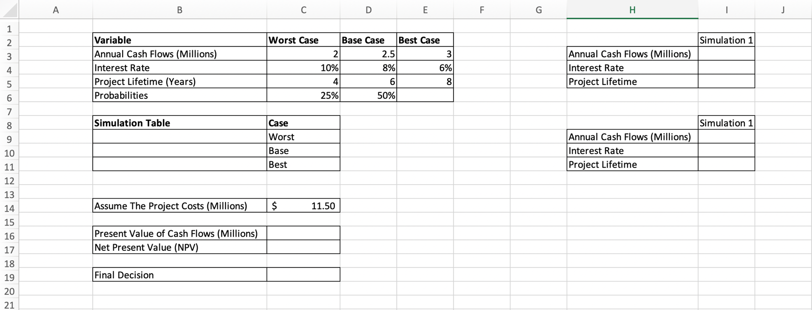

- Given 2 probabilities: 25% for Worst Case and 50% for Base Case
What is the missing probability for Best Case? __________
Fill in cell E6 with the missing probability.

- Simulation Table:
We use the simulation table to provide the information needed for the formulas we will use.
Based on the probabilities, we know the first constraint on our table should be 0-0.25 because the probability for Worst Case is 25%.
Since the first constraint is 0-0.25, adding the 50% probability for Base Case, we get our second constraint to be 0.25-0.75.
Our last constraint should be ___________. This is because that is the remaining portion of the probability distribution.

- Our excel spreadsheet should now look like this:
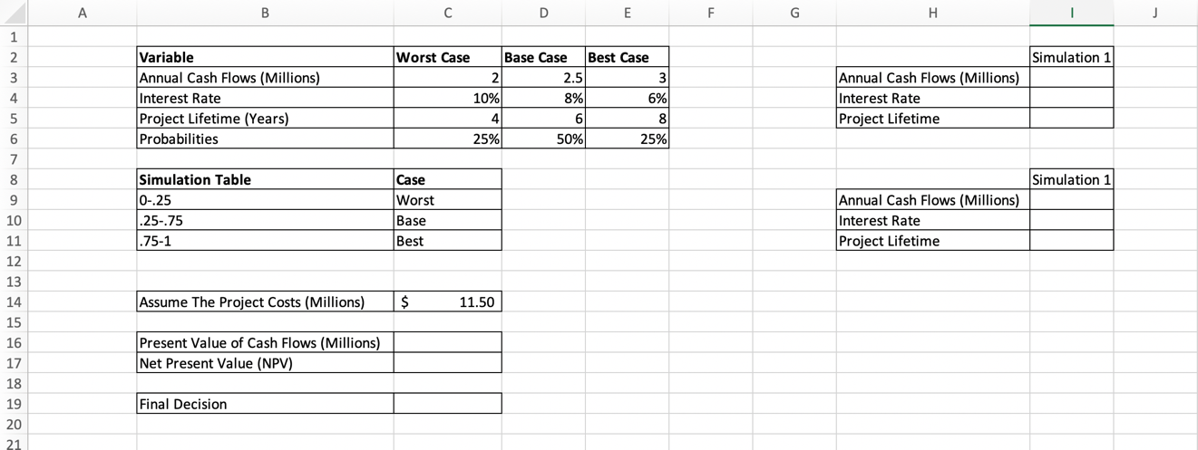

- We will now look at the table that is highlighted on the picture below.
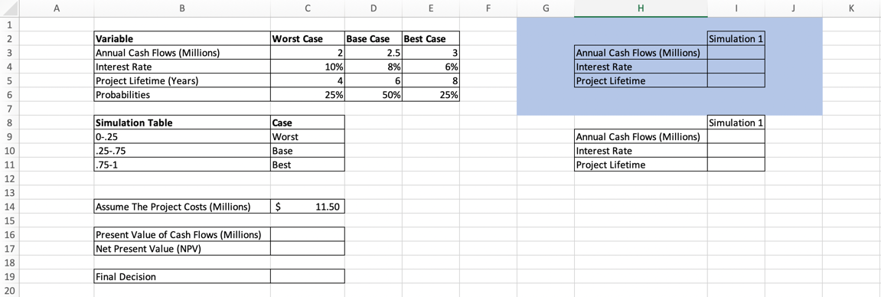

Starting in cell I3, we will input a random number formula and permanently paste those values so they do not generate multiple times during the assignment.
To do this, we will input =RAND into cell I3 and drag down to cell I5. Now copy all 3 cells and in the top left hand corner find the paste button and hit Paste Values.

- Now we have the random values we need to fill out the table highlighted in the picture below:
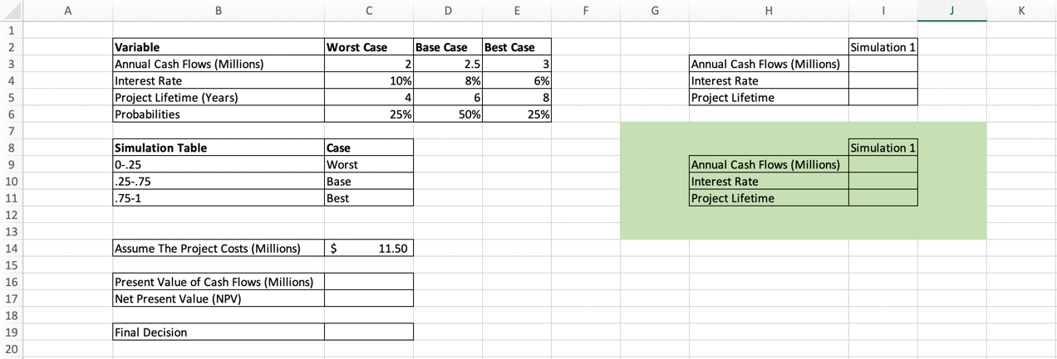

Starting in cell I9, for the annual cash flows, we will input the following formula:
=IF(I3<0.25,C3, IF(I3<0.75,D3, E3))
Then drag the formula down by selecting the first cell and dragging your cursor to the end of cell I11. The formula should stay and calculate the interest rate and project lifetime.

- Now we will look at the tables highlighted in the picture below:
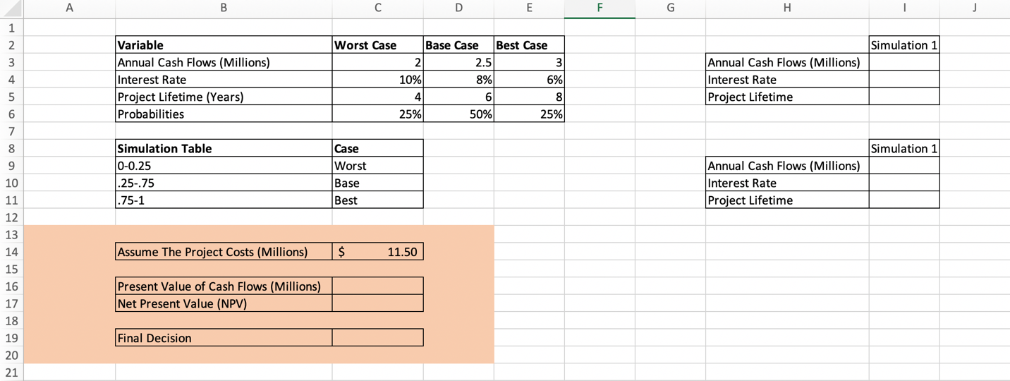

These tables will reference our data so far and help determine whether we should invest in the project for our company or if we should decide to not complete the project because it will result in our company losing money.

In cell C16, we will input the following formula:
=-PV(I10,I11,I9,0,0)
This formula will determine the PV of the simulated cash flows.
The “Present Value of Cash Flows (Millions)” indicates how much revenue the project would generate based on our simulation in today’s dollars.

In cell C17, we will input the following formula:
=C16-C14
This formula subtracts from our present value the cost of the project at time 0 (C14) to determine what our net cost of the project will be, or the “Net Present Value (NPV)”. The NPV is also calculated in millions.

In cell C19, we will input the following formula:
=IF(C17>0, "Invest", "Don't Invest")
This formula shows that if the NPV is greater than 0, then we are making a profit on the project and should invest our money into it since it will add value to the company.
If the NPV is less than 0, then we will lose money and therefore should not invest.

